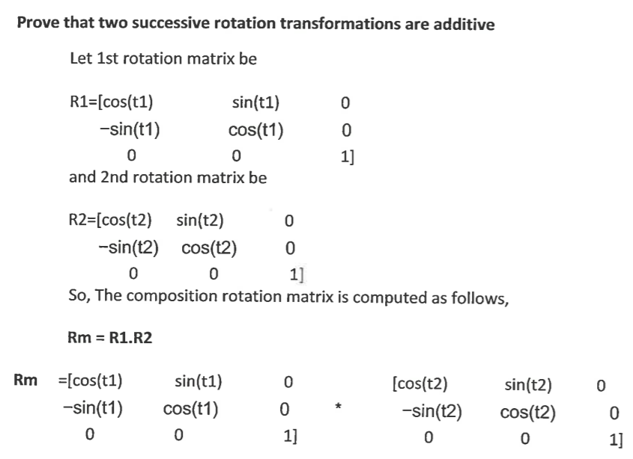

Also find that Rm=R2.R1

Hence it is verified that two successive rotations are additive